Intelligent Security System for Women & Child Safety
Mo. Siddiqe Memon¹, Shivani C. Bhandakkar², Vaishnavi R. Bhalekar³, Dr. D.G.Ganage⁴
^{1,2,3}BE Students, Dept. of Electronics & Telecommunication Engineering,
⁴Professor, Dept. of Electronics & Telecommunication Engineering,
Sinhgad College of Engineering,
Pune, India

ABSTRACT
In today’s world, Women security is a major issue of concern. Women are facing many problems such as women harassment, rapes, etc. It is an accepted fact that brutal crimes against women are occurring in India daily. Now many Indians do not even deny or shy away from conversations relating to eve-teasing, sexual assault or rape. We propose to have a device which is the integration of multiple devices, hardware comprises of a wearable “Smart Band” that endlessly communicates with phone. It is a device used for the women in a chaotic situation. The basic approach is to use the Arduino Uno microcontroller based on ATmega328P has the function of send and receive data which is provided by Arduino GSM shield using GSM network. Arduino Uno gets the coordinates of the current location through the GPS Module; it transfers the coordinate details to the user’s smart phone via Arduino GSM shield. With this we have an additional feature of security of blind person which works like a blind stick. If a blind person is walking in the crowded place or on road & if any obstacle gets detected within a certain range in front of the Blind person, then the alarm will get activated & will inform the person about the obstacle.

Key words: Arduino GPS and GSM Module, Arduino Uno (ATMega328P), DS18B20 Body Temperature Sensor, Heartbeat Sensor.

- INTRODUCTION

Women safety has become a matter of utmost concern in the current times. Most cases of women harassment occur due to the lack of proper help at the right time to the victim. With the advancement of technology many systems has evolved that serve as an aide to women in dangerous situations. As the cases of women harassment are increasing day by day, so we tried to build a device which can be useful for a woman in distress. Although there exists many security systems, an advanced smart system is a necessity. This project proposes a smart security device to help women to be safe during times of utmost danger.

Various apps & devices are designed for the safety of Women & Child & also for the blind person. As per the survey in Sept. 2020, India recorded an average of 87 rape cases daily and overall 4,05,861 cases of crime against women during the year, which is a rise of over 7% from 2018. So, safety has become a very important aspect for the women & child now-a-days.

This device comprises of an Arduino UNO board, various sensors to monitor the body parameters variations, GPS & GSM modules. When a device notices abnormal variations in the body parameters the distress message with location coordinates is sent to the registered contacts.

This device also works for the Blind Person Safety. For this we’ve used an ultrasonic sensor which will alert the person if any obstacle is detected in front of the person by triggering an alarm, it acts as a blind stick for the blind person.

- LITERATURE SURVEY
“Intelligent Security Systems for Women by using Arduino” by Mr. V. Nanthakumar, Ms. G. Hariprabha, Ms. D. Jasmine, Ms. B. Keerthana, Department of EEE, Sengunthar Engineering College, Tiruchengode, Tamil Nadu, India dated 2019. This paper introduces a new device, security system specially designed for women in distress. Women can press the button that is attached to the device and the location information is sent as an SMS alert to few pre-defined emergency numbers in terms of latitude and longitude.
“Design and Implementation of Women Safety System Based On IoT Technology” by B. Sathyasri, U. Jaishree Vidhya, G. V. K. Jothi Sree, T. Pratheeba, K. Ragapriya, Department of Electronics and Communication Engineering, Vel Tech, Chennai, India dated 2019. This paper covers descriptive details about the design and implementation of “Smart Band”. In this project when a woman senses danger she has to hold ON the trigger of the device. Once the device is activated, it tracks the current location using GPS and sends emergency message using GSM to the registered mobile number and near by the police station. IoT module is used to track the location continuously and update into the webpage. The main advantage of this project is that this device can be carried everywhere since it is very small.
“Women Safety System using Arduino UNO and Integrated Safety App” by R Anitha, Valliammai Engineering College, Kanchipuram, Tamil Nadu, India. This paper discussed a device called as “Virtual Friend”, specially designed for women in trouble. The basic approach is to use the Arduino UNO microcontroller based on ATmega328P has the function of send and receive data which is provided by Arduino GSM shield using GSM network. Arduino UNO gets the coordinates of the current location; it transfers coordinate details to the user’s mobile via Arduino GSM module. The SOS light is a signal used to alert the passerby and it gives the sign of universal help to the victim who is in distress. The alarm buzzer is activated if the woman is in danger situation. In the critical situation, the woman send the message or make a call including the location of the particular incident to the registered mobile numbers through the use of GSM and GPS.
Sr.No. | Name of Project | Advantages
1. | Intelligent Security Systems for Women by using Arduino | It informs about the situation using text message with her GPS location due to which instantly she gets the help.
2. | Design and Implementation of Women Safety System Based On IoT Technology | This system starts the alarm due to which the people in the surrounding should be informed & get instant help.
3. | Women Safety System using Arduino UNO and Integrated Safety App | As there is app with this system, it is very small in size & can be easy carried.

- PROPOSED SYSTEM

Figure1 shows the block diagram of Women and Child Safety & Figure 2 shows the design algorithm for Women and Child Safety.

Figure (1) Block Diagram for Women & Child Safety

Figure (2) Design Algorithm for Women & Child Safety
When the power supply of the project is switch & if the switch of the project is in ON state (Women & Child Safety Mode), then all 3 sensors starts checking the value and the GPS & GSM Modem gets initialized. Controller will continuously receive the commands from all the sensors. Let’s assume that a women / child is getting harassed, then the parameters such as temperature, heartbeat, etc. gets increases. If any of the 2 sensors detects the value above the threshold then a signal is sent form the controller to the GSM & a text message is sent to the contact number which is feed in the project i.e relative, control room, etc.

Figure3 shows the block diagram of Blind Person Safety & Figure4 shows the design algorithm for Blind Person Safety.

Figure (3) Block Diagram for Blind Person Safety Figure (4) Design Algorithm for Blind Person Safety
If the switch of the project is changed from ON state to OFF state then the project will start working in Blind Person Safety Mode. Then the Ultrasonic sensor will continuously senses the parameter & if the value crosses the threshold, then the controller will send the signal to the Alarm. If an obstacle is detected, Alarm will be activated & the person will be informed about the harm.

- RESULT
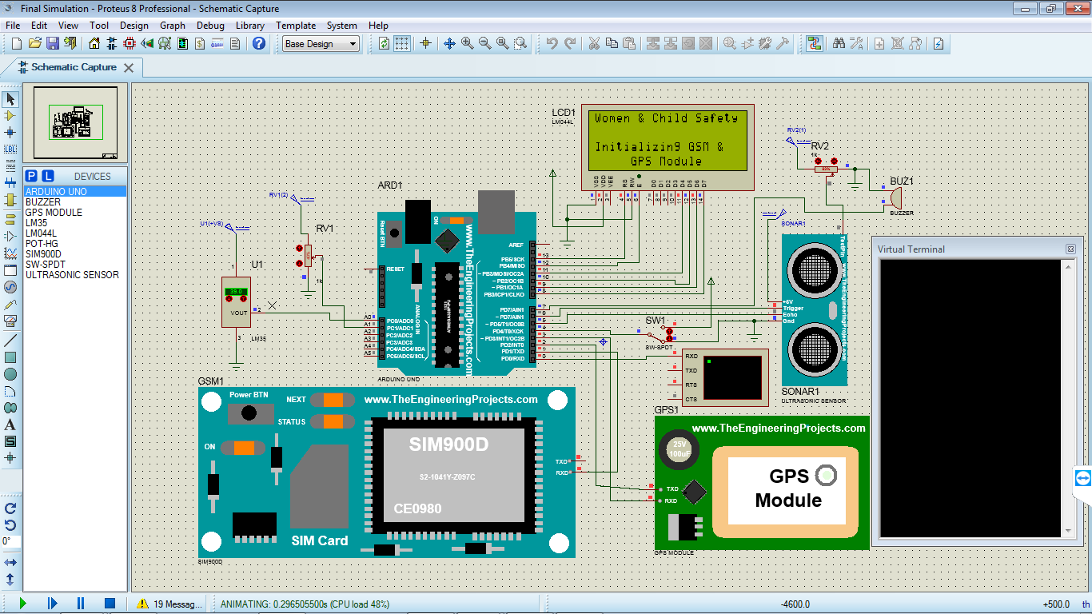
Fig 4.1 When project is turned ON
The above fig. displays the initialization of the project. When the project is turned on & the switch SW1 is in Women Safety Mode, then “Women & Child Safety – Initializing GSM & GPS Module” is displayed on the LCD and the GPS & GSM module is also initialized.
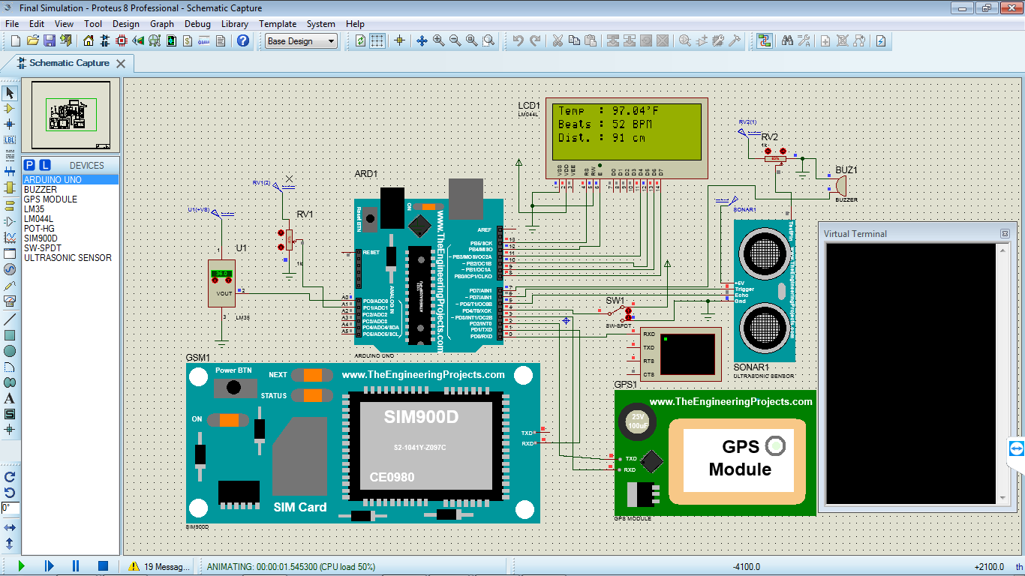
Fig 4.2 Simulation of Women & Child Safety(Normal Condition)
After the initialization of the project, all the sensors will start sensing the parameters such as Temperature, Heartbeats, Distance. In the above fig. temperature & distance is in the desired range but only heartbeat is below the desired level. So, as only one parameter is not in the threshold value then no action will be taken. Because as two sensors value will cross the threshold, then a message will be sent on the mobile number which is fed in the program.

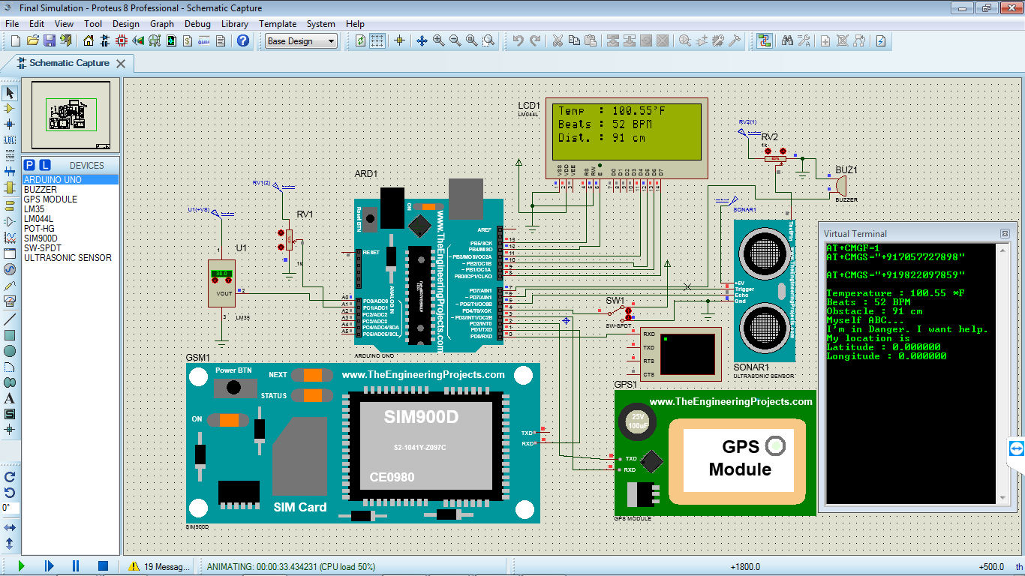
Fig 4.3 Temp. HIGH & Pulses LOW
In the above fig., two sensors values have crossed the threshold value i.e temperature value is above 100 & pulses (heartbeats) is below 60. So, a message will be sent to the registered mobile number. The message will be the parameter values & “Myself ABC…. I’m in Danger. I want help” & the location coordinates of the particular person who is being harassed.
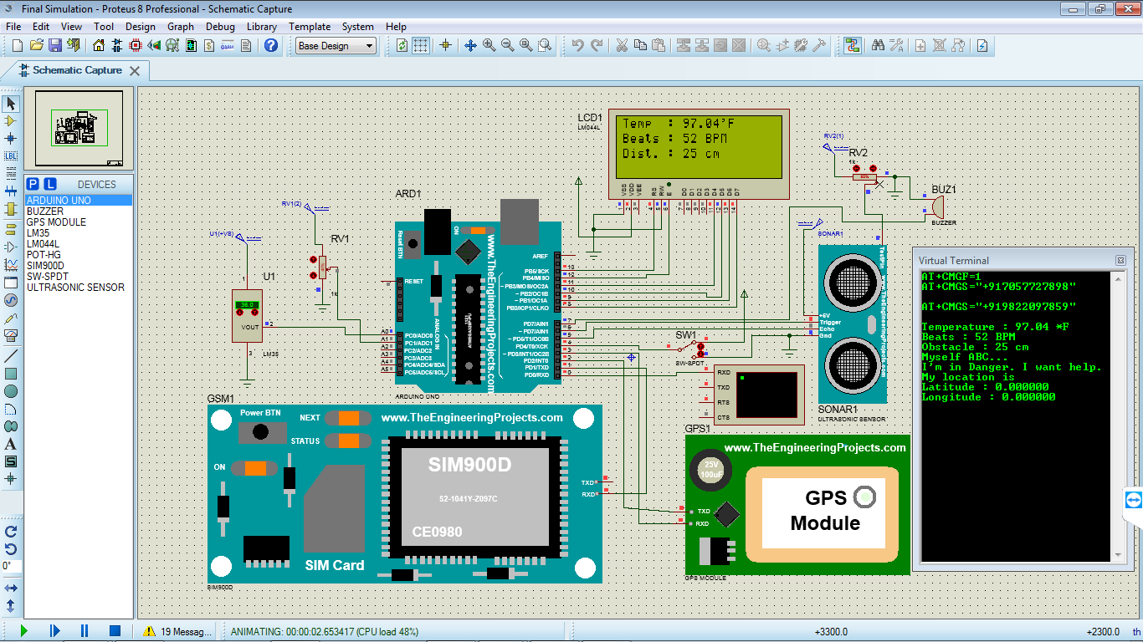
Fig 4.4 Pulses LOW & Short Distance
In the above fig., two sensors values have crossed the threshold value i.e Distance is below 50 & pulses (heartbeats) is below 60. So, a message will be sent to the registered mobile number. The message will be the parameter values & “Myself ABC…. I’m in Danger. I want help” & the location coordinates of the particular person who is being harassed.

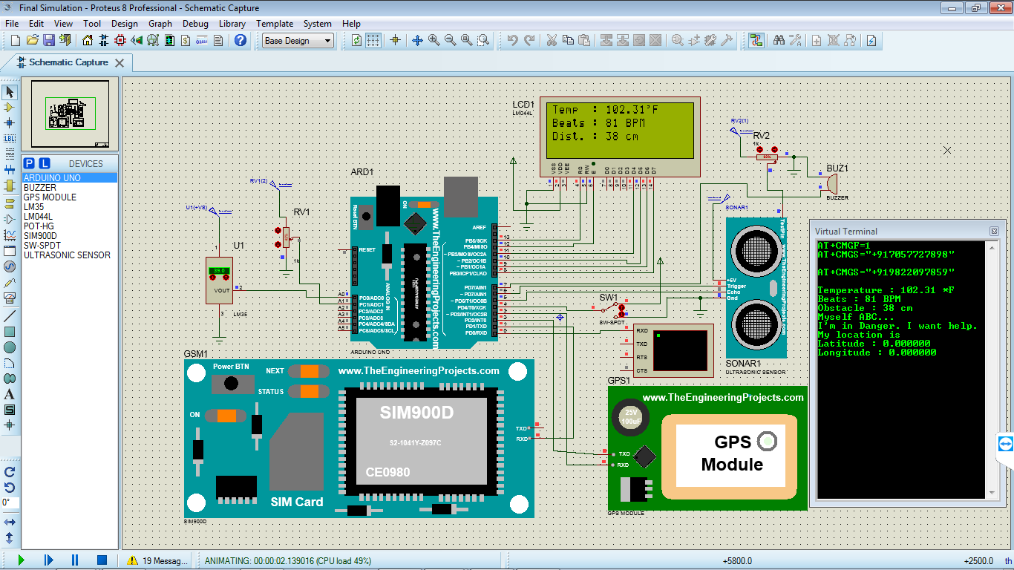
Fig 4.5 Temp. HIGH & Short Distance
In the above fig., two sensors values have crossed the threshold value i.e temperature value is above 100 & distance is below 50. So, a message will be sent to the registered mobile number. The message will be the parameter values & “Myself ABC…. I’m in Danger. I want help” & the location coordinates of the particular person who is being harassed.
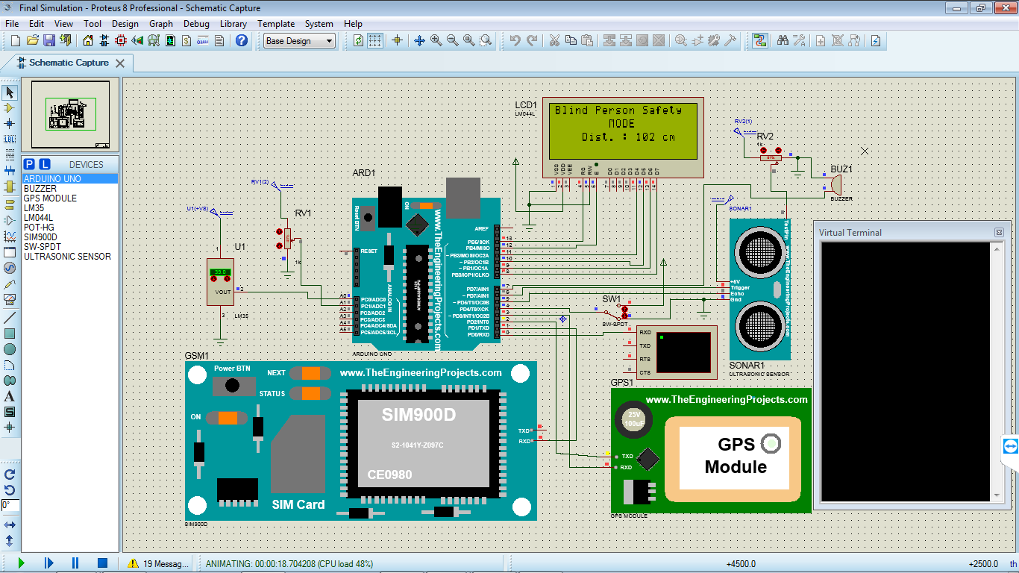
Fig 4.6 Simulation of Blind Person Safety (No Obstacle Detected)
The above fig. shows the project in Blind Person Safety Mode. As the switch SW1 is changed from ON to OFF then the mode of the project will be changed from Women Safety to Blind Person Safety. In this mode, if the distance is below 100cm then Buzzer will be turned ON, which will indicate that the obstacle is in front of the particular person. But in the above fig., distance is above 100, so it will take no action.

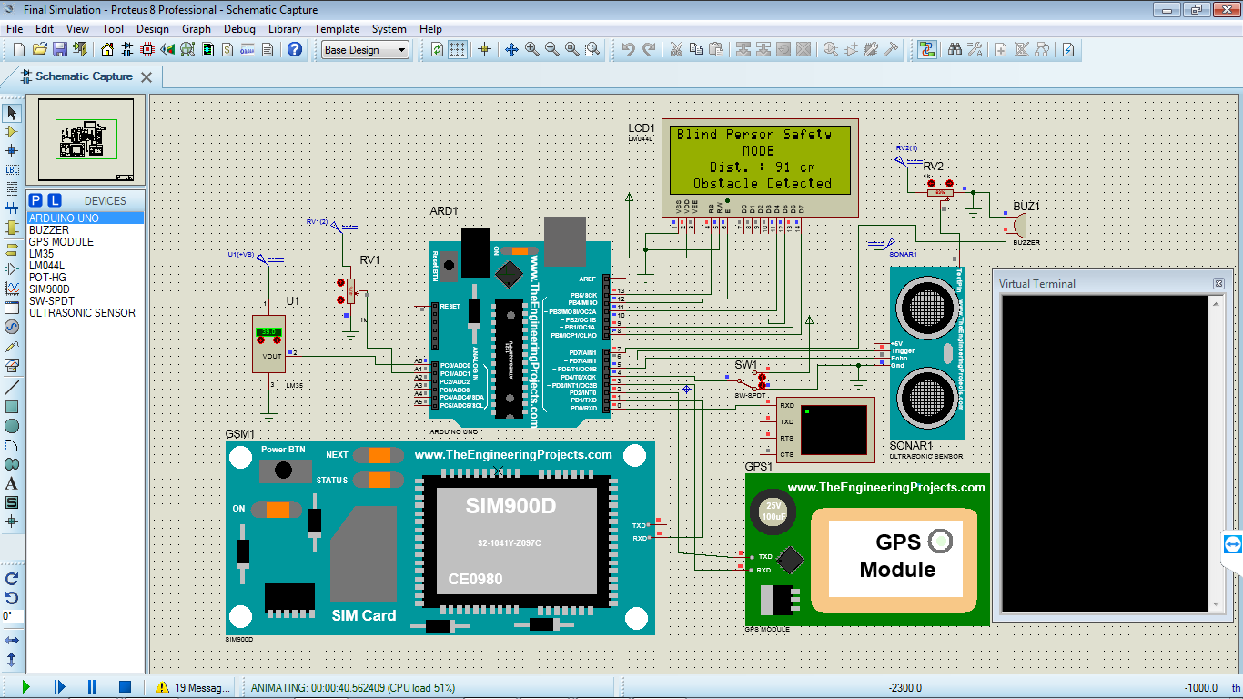
Fig 4.7 Simulation of Blind Person Safety (Obstacle Detected)
In the above fig., the distance is below 100, so as the sensor crosses the threshold value, the Buzzer will be turned ON & it will indicate that some obstruction is in front of the particular person & also message will be displayed on the LCD screen i.e. “Distance of the Obstacle & Obstacle Detected”.
- CONCLUSION
We have designed a Intelligent Security System for Women & Child Safety which also includes the Blind Person Safety using low-cost components, and included the message facility due to which the relatives / friend, etc. will be known about the location & the situation of the subject, due to which they can give the subject an immediate backup or help. As the system is small & will be packed in a small box, it will be easy to carry anywhere. Also it will help the blind person for avoiding him/her from getting harm. Also, this system will deal with critical issues faced by the women & will help to solve them with technologically message facility & ideas.
- REFERENCES
[1] Mr. V. Nanthakumar, Ms. G. Hariprabha, Ms. D. Jasmine, Ms. B. Keerthana- “Intelligent Security System for Women by using Arduino” International Research Journal of Engineering and Technology (IRJET), Volume 06. 2019; pISSN 2395-0072.
[2] B. Sathyasri, U. Jaishree Vidhya, G. V. K. Jothi Sree, T. Pratheeba, K. Ragapriya- “Design and Implementation of Women Safety System Based on IoT Technology” International Journal of Recent Technology and Engineering (IJRTE), Volume-7 Issue 6S3. 2019; ISSN 2277-3878.
[3] R Anitha, “Women Safety System using Arduino UNO and Integrated Safety App” International Journal Of Advance Research, Ideas and Innovations in Technology (IJRTE), Volume 4 Issue 3; ISSN 2454-132X.
[4] R. A. Mahajan, Sayali A. Lavhate, Sayalee P. Waghmare, Prerana K. Pingale, “A Survey on Women’s Security System Using GPS and GSM”, International Journal of Innovative Research in Computer and Communication Engineering (IJIRCCE), Volume 5 Issue 2. 2017.
[5] Dongare Uma, Vyavahare Vishakha and Raut Ravina, “ An Android Application for Women Safety Based on Voice Recognition”, International Journal of Computer Science and Mobile Computing (IJCSMC) online at www.ijcsmc.com, Vol. 4, Issue. 3; March 2015; ISSN 2320-088X
[6] Swapnali N.Gadhave1, Saloni D. Kale, Sonali N. Shinde and Prof. Amol C. Bhosale, “Electronic Jacket Form Women Safety”, International Research Journal of Engineering and Technology (IRJET), Vol.4 Issue.5; May2017; pISSN 2395-0072
[7] Subrata Ghoshal, “Embedded Systems and Robots Projects using the 8051 Microcontroller”, Cengage Learning Asia; 2009-06; ISBN10 : 9814272892; ISBN13 : 9789814272896
[8] A. Tekade, M. Sonekar, M. Ninave and P. Dongre, “Ultrasonic Blind Stick with GPS Tracking
System”, in International Journal of Engineering Science and Computing, March 2018.

[9] GPS tutorial. http://www.trimble.com/gps .
[10] GSM Arduino.https://www.arduino.cc/en/Reference/GSM
[11] Study of Arduino UNO. https://components101.com/microcontrollers/arduino-uno
[12] Ultrasonic Blind Walking Stick Using Arduino. https://www.circuitstoday.com/ultrasonic-blind-walking-stick

